Calvino “fantasy is a place where it rains”

Between the two of them, whilst being disparate in form, they form a tight, small, rich local network of meaning and interaction between themselves, apart from the interaction between creature and player.

Most horror games are all about environment.

Floridi - 'engineering the world' - you must provide a dumb gadget with a sympathetic surrounding environment. The world is becoming that environment, and do not need to put a big box around it - same with the creature?

Reading vs. Observing. Reveals different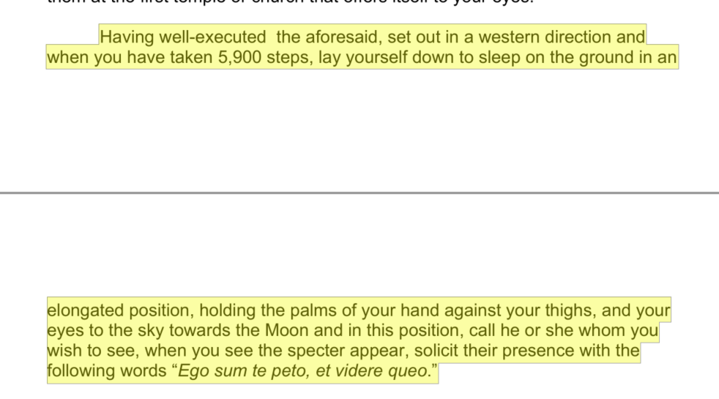 things.
Palliative Care

John Dixon Hunt - reception theory in landscapes.
- Not just bodily - dealing with ‘total suffering’.
- Can be the cause of abusive behaviour “the taxing nature of showing compassion for someone whose suffering is continuous and unresolvable”.
Link to cellular automata -> nature as system, not mechanism.
Genetic Algorithm

Link between nature and mathematics - pattern-matching in the grimoires.
SOyga - about combining letters and numbers in this way.
- The lunar manisons, gebnealogies of angels, lists of conjunctions.

These algorithms mimick biology, naively getting fitness of each generation, introducing random mutation, mixing different parts, promoting diversity, crossovers, and picking the best results from different variables.
"Even in reading the most technical scientific book or the most abstract book of philosophy, one can come across a phrase that unexpectedly sitimulates the visual imagination"

Relating to reader-response theory in terms of the text as a guide to creating meaning.

Ritualising as games (harry giles)

The creature is a landscape that she can tend, that she likes, that she can understand, that does not affect her.
Britannia - character as environment.”

RPS article on manuals - Diablo shipped with a gorgeously elaborate manual. It didn’t just have little blurbs about what the controls did. It had a bestiary of monsters. Descriptions about the backgrounds of the weapons available. It dove into the history of the universe, the socio-political structure of its cosmology.

Translation of scripts

An introduction to the main event in the game - not a thing in and of itself - refer back - contextual - can it be enjoyed on its own?

Clues about hidden areas

Scratch and sniff in Earthbound

A strategy guide for interacting with unpredictable systems,

Super Mario Bros.
There’s a bit of a dark past hidden in Super Mario Bros.’ booklet. The story, as described in the manual’s first few pages, involves the Koopa tribe turning the Mushroom Kingdom’s residents into bricks, stones, and “field horsehair plants” (commonly considered the game’s Fire Flower power-up). This would mean that Mario is actually shattering bricks with human souls when he grabs coins and ingesting people to throw fireballs. The sordid implications were eventually ret-conned, but the original manual stands as a sort of morbid tome to the Mushroom Kingdom’s sordid past.

Grimoires are books that contain a mix of spells, conjurations, natural secrets and ancient wisdom. Their origins date back to the dawn of writing and their subsequent history is entwined with that of the religions of Judaism, Christianity and Islam, the development of science, the cultural influence of print, and the social impact of European colonialism."

Caroline A. Jones (in Evocative Objects) - artworks “solicit us to be their subjects and, in turn, the authors of their meanings, at least for a while.”

Artifice article
players never even have any physical traces that the game exists.

One of the greatest NES game manuals (and one of the greatest NES games in general) is the one that came packaged with the original The Legend of Zelda (1986), with its shining gilded cover and plethora of stories, hints, original, hand drawn artwork, and even a map of the beginning of the game.

But there is a certain magic in holding the instruction manual, that thin little booklet, and scouring over the tale, as if reading some ancient document.

But there is a certain magic in holding the instruction manual, that thin little booklet, and scouring over the tale, as if reading some ancient document.

Game manuals are less useful now that game graphics can introudce the world so much better.

The instruction manuals allow games to get right into the action, allowing players to resort to them only when necessary.

The internet has made finding secrets much easier. Another reason to isolate this game.

This isn’t to say that some of the magic and mystery is gone from finding secrets in games, as there is a certain charm in working together on a message board or looking up tips on Youtube. But the dusty relic that is a game manual was an important part of the gaming experience for nearly a decade, and it is a shame to see it fall into obscurity.

One of gaming’s most infamous instruction manuals, the booklet for StarTropics (1990), an action-adventure game for the NES, features one of the most engaging and striking uses of meta in a video game (meta refers to something outside of the actual game). Attached to the game’s manual was a yellowed piece of paper, supposedly resembling parchment, that held a secret code within its fibers that could only be seen when some water was rubbed over the paper. During the quest, protagonist Mike Jones is told to “dip [the] letter in water,” and players are tasked with figuring out what this means.

StarTropics - letter
StarTropics – letter
The act of playing through the game and figuring out the mystery is quite the experience, and nothing quite like it has ever been done since. Since most players bought the game used, without a manual, the code was constantly published in Nintendo Power, but for those that solved the puzzle firsthand, it remains a great moment in gaming. The Virtual Console release of the game includes the letter in with the digital manual, and at the bottom of the screen is a small pail of water, which is Nintendo’s way of trying to be true to the material.

Now with 'special editions'

A book separates from other ecosystems.

The simple answer is no, there isn’t really a need for publishers to print out these manuals that no one will read.

physicality and immersive qualities of the instruction manual.

There's a charm to them.

Age three and over. Full instructions supplied.
Figaro, the famous feline from the Disney classic
"Pinocchio," is now a "magical" lifelike companion!
The cute and loyal pet of Geppetto loves to be
"fed" and comes with a special bottle for feeding.
He even responds with eating sounds when you
feed him.
A special sensor on his back triggers realistic
padding and kneading movements as well as
purring and meowing sounds. The more you love
and play with Disney’s Figaro the more he’ll
respond and love you back!
Be sure to take good care of Figaro by following
the instructions in this booklet!

Like a book, the creature needs a ‘recto’ and ‘verso’ - a “comparative visual space” (edX). Thus, a mirror of itself? Isn’t the ‘holy manual’ its ‘verso’?
The book as a ‘comparative visual space’.

Noah reading the book of enoch as an instruction manual for the ark - ancient knowledge.

Retire thou then unto a secret place, where no one may be able to see thee or to
hinder thee, before the completion of the experiment, whether thou shouldest wish to
work by day or by night.
Character as a deliberate-and-accidnetal arising from interpretation of emergent systems.
Naturalistic dualism - non-physical entities arise from physical systems, but are substantially different.
Consciousness is an example of this.
Why restricted to a head?

The ‘other third’ of my PhD practice: a codical companion to my simulated creature, designed to complement its fiction and provide a structure to interaction with it. A cross between a holy text, an instruction manual, an old-fashioned videogame cheat book, videogame tutorials and a guidebook to the creature as landscape.
Spackman & Miller - somatic approaches to emotion (bodily) - character as environment. The Heideggerian/Ponty approach sayas that environments and bodies mutually constitute each other.
For Bryson, no steady state in characters - always a moil and roil.
“Not considered [as witches]”
“Shrewd, calculating entrepreneurs”
Many owned grimoires
“Fortune-telling manuals” used most often - the creature is a fortune-telling manual.
“Theatrical flourish helped to present an air of the unusual”
Hedier and Simmel - slight movements are just as important as big, expressive movements, albeit in a different way. Games are all about the big movements. Apart from in the environment.
Heideger - “no wild animals roams at random over the country.”
Anthropocentric, mechanomorphic, creature-as-machine, estranging you from the creature itself.
Fixed rhythms of natural life - “forces they cannot control” (heideger)
PARRY demonstrated emotions
Heidegger/Merleau-Ponty
The meaning of an emotion is not dependent upon a representation in the mind of the emoter (which depends upon 370 M. P. Spackman, D. Miller 123 another representation, etc.), but it grows, exists, develops with and as a part of the emotion.
Brooks’ approach is not Heideggerian but is similar - robots that are embodied in themselves.
Power Dynamic (Supplication vs. Mastery)

- Zoology consists of observation of changes in marked cycles. A zoology simulator is what I’m doing, then.

Honorisu - lots of latin and hebrew names, obscure bible references. Requires length planning, expensive ingreedients - meant to be exclusive, makes it seem more impressive, deters sceptics because of the high cost of testing theories. A guidebook to mediating relationships, a precise and localised landscape - the summoning circles etc. It will tell you what to pack, what to wear, the customs of the inhabitants etc. Very funcitonal ,tells you precisely what to do; transcends its own mysticism What vaccinations you need, currency, the costs of things.

Homeostasis - The relatively stable equilibrium-state between many interoperating parts in a system.

A guide to interacting with a reactive system.

To Hinder a Sportsman from Killing any Game.
Take a stick of green elder, from the two ends of which thou shalt clean out the pith.
In each end place a strip of parchment of hare-skin, having written thereon with the
blood of a black hen the following character and word. (See Figure 7.) Having made
two of these slips, place one in each end of the stick and close the apertures up with
pith, afterwards on a Friday in the month of February thou shalt fumigate the afore-
said stick with suitable incense thrice in the air, and having taken it thence thou shalt
bury it in the earth under an elder tree. Afterwards thou shalt expose it in the pathway
by which the Sportsman will pass, and once he has passed by it, he need not hope to
kill any game during that day. If thou shalt wish a second time to lay a spell upon him
in like manner, thou needest but to expose the stick again in his path; but take care to
bury it again in the earth under an elder tree, so as to be able to take it from thence
each time that thou shalt have need of it; and to take it up each time as soon as the
Sportsman shall have passed.

It is a literal key - a legend for a map. Etymology - to be read first/

A psychopomp text

The nature and character of landscapes I have seen; coastline at Newquay, holloways in Kent.

Attention - Victor Shklovsky, in the
early essay Art as Device (1917), empha-
sized that the deformation of reality,
‘making strange’ or ‘defamiliarization’
(ostranenie), was central to all art. He
claims that the habitual nature of every-
day experience makes perception stale
and automatic, but
art exists that one may recover the sen-
sation of life; it exists to make one feel
things, to make the stone stony. The
purpose of art is to impart the sensa-
tion of things as they are perceived
and not as they are known. The
technique of art is to make objects
‘unfamiliar’, to make forms difficult,
to increase the difficulty and length
of perception because the process of
Formalism 93
perception is an aesthetic end in itself
and must be prolonged. Art is a way
of experiencing the artfulness of an
object; the object is not important.

The study of literary
texts with reference to the interaction
between human activity and the vast
range of ‘natural’or non-human phenom-
ena which bears upon human experience –
encompassing (amongst many things)
issues concerning fauna, flora, landscape,
environment and weather.

Global Warming - effecting a system over time.

Murray - Digital environments are “procedural, participatory, spatial and encyclopedic.”

Recipes in holy manual like recipes in leechcraft

She thinks that simulations most capture what computers are capable of - a virtual world “we can enter, manipulate and observe in process” - character as environment.

“For many, computer programming is experienced as creating a world apart”
The manual is explicitly on the PLAYER’S side.
The grey box approach.
Use stuff in chapter 1 as an example of the autocosmifying of landscape - witchcraft, supersition and the environment,.
Rules for interacting with it.
The housekeeping is also a guide to Nighthead - “in our village”
New Yorker - Miyamoto is all about environments. “Hyrule, he once said, is “a miniature garden that you can put into a drawer and revisit anytime you like.””
Can talk about grimoires a bit here - guidebooks to the landscape that superstition and learned magic described - the “landscape beyond the landscape”.

Hutton (95) links the sorts of ailments that charmers focus on to the human nervous system - rapport with patient led to psychosomatic response - Theo Brow (1950s) - noted success rate to be total.
P. 96 - the use of a mirror, crystal etc. To put the onus on the viewer, bring up suspicions that already existed. Rely on autocosmics -> the creature is a mirror.
“Sympathetic magic involving fire” - voodoo nature.
“Any lingering and mysterious malady was liable… to be blamed upon witchcraft.”
“The drama and complexity of the ritual involved in them clearly functioned as an excellent antitdote to feelings of depression and persecution.”
They describe how to do the actions in the game - not every action, just the most applicable ones.
Sometime reveal gameplay/story mechanics (I.e. “Fly Jet”)
Specific, deterministic controls.
Glyphs for mouse movements and things like that.
Keyboard covers, even.
Tables
Capitalised letters for ontological importance, with strange names. Must learn the parts of the system, strange characters in a new cosmology. Ontologies are a way to corral rampant paracosmics.
Tips for specific narrative points - my version of tips? Things about the creature? Weaknesses?
Black & White manual sees the problems of just being good all the time, encourages evil.
Describing ALL behaviour. What will happen when you do something. Mine is less straightforward than that.
The Future Room -
“Who knows what the future holds? This room is filled with the mysteries therein.”
"In addition to collecting published information, cunning folk wrote their own notebooks, of information taken from other printed works or word of mouth."
"the feminine, the night, wild nature... had been subordinated, feared or derided in Western culture since the triumph of Christianity"
Instructional Poetry (Neil Gaiman)
Ever want to jump into your favorite story or
fairy tale? Famed fantasy writer Neil Gaiman
gives us some guidelines. The world of the
imagination is indeed exciting, exhilarating,
and even somewhat scary. But as great stories
teach us, it is always worth the journey. Go
ahead. You'll be fine.

Who to trust and who not to trust (in a strange land). Don’t trust the book! Do the opposite of what it says!
“Fallout 2 survival kit” - the theatricality of the physical parts of the product
“Property of vault-tec” on every page
Written as memoirs
Notes in the margin - in handwriting - used for in-character musings and tips.
Often must tell you about plot points in the game to explain their use, even before they have been revealed in the game. An interesting extra-narrative effect.
The “voice” of the manual is a bit confused.
Recipe in the back of the Fallout 2 manual?? And conversion tables? LIKE A GRIMOIRE.

Black & White Manual - “people who need a god always get one”.
“Learn the following controls to help you rule your worlds.”
“Here are some hints and information on how to be an efficient and effective god.”

Leechcraft as a guidebook and interpreter of enviro.

Leech craft - If the patient truly
believed that such a remedy would provide relief and if that patient had complete faith in the leech
who was tying the madder to the head then the often quoted ‘placebo effect’ could cause this
remedy to be effective. One cannot truly judge the efficacy of Anglo Saxon medicine without
replicating the conditions and the mindset of the times – an impossible task

Leechcraft - instructions rife with Christian and pagan imagery.
They believed sudden pain was elfshot and witchshot - anthropomorphising
From Leechcraft - Griffiths suggests that the repetition and alliteration evident in
charms may not only have aided memory but also have an emphatic quality ‘indicating the assumed
power of statement over event’ 19

The manual is a memorial to him as well.

Often drawn in the background (pretty cursorily) as a book of holy knowledge, with pages and everything.

“Parallel exploration paths” mentioned in Uru manual.
Explains everything, even which individual paths you might be following - so desperate for you not to miss the significance. Is this really different from book blurb? How often do we encounter a book outside its commercial context.

Installation always comes first.

